## Progress update: Report on and summarize preliminary research findings to date.

Below are preliminary results of the adjacent state sample for Demographics (section 1), Place Attachment and Place Preference (section 2), Push and Pull Factors (section 4), and Affective Imagery Study (section 5).

### 1) Demographics

The adjacent state sample consists of respondents from all 10 states that were targeted. The distribution is largely reflective of the population across states, except for an over representation from Connecticut and under representation from New Jersey and Massachusetts.

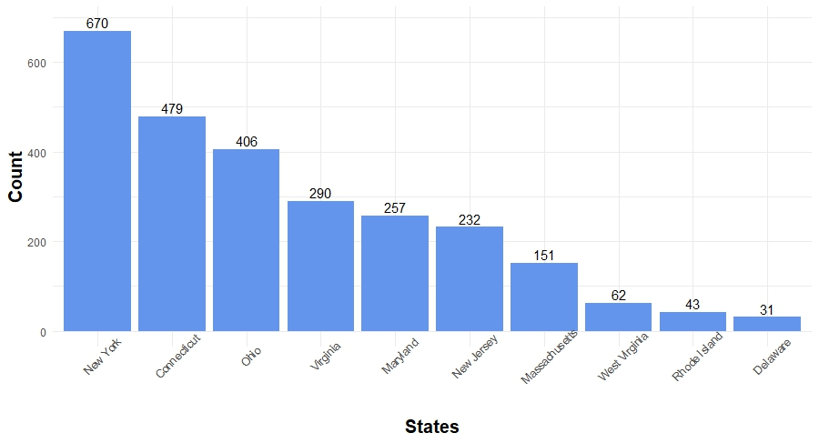

From the figure, it is notice approximately 26% of the people live in New York & 1.18% people live in Delaware.

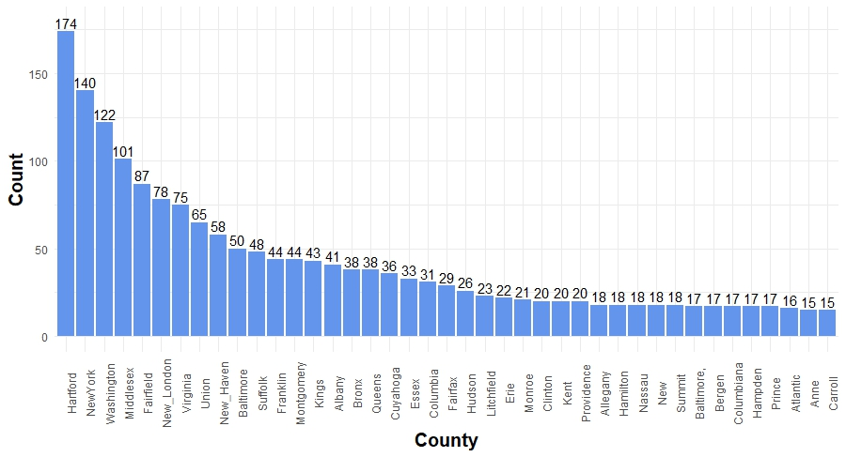

From the figure, it is noticed that the most of the people live in Hartford.

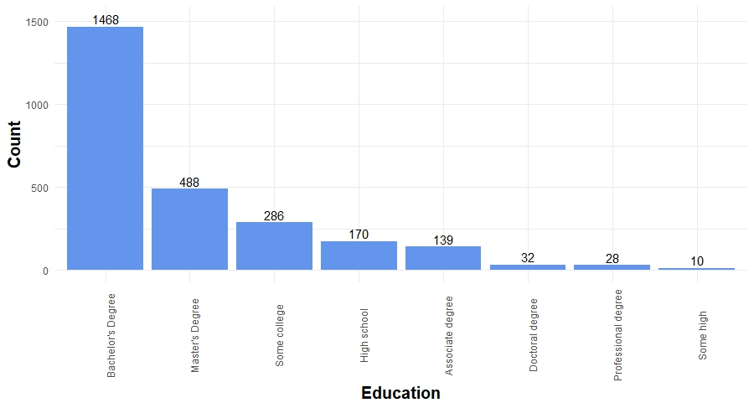

In this study, it is found that the most of the respondents (56%) have Bachelor’s degree.

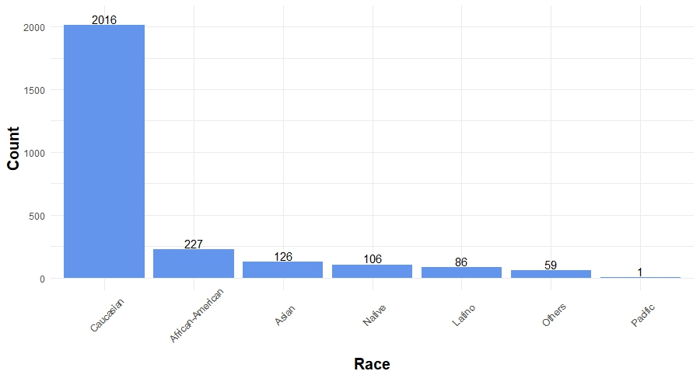

In this study, it is found that 77% of the respondents are Caucasian (white) & 0.03% of the respondents are Native Hawaii or Pacific Islander.

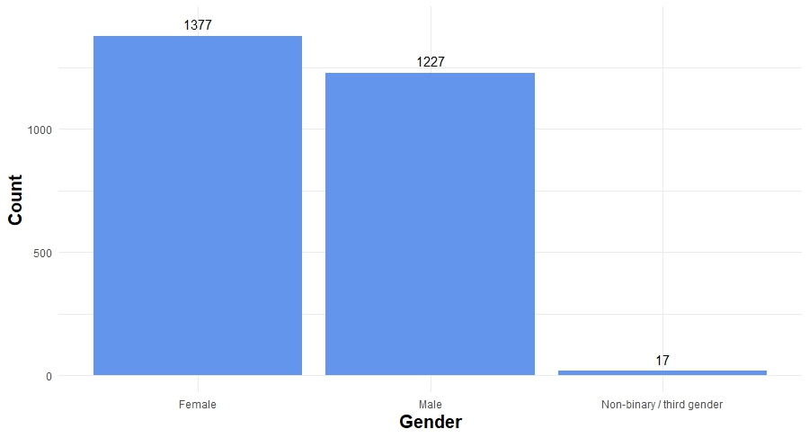

In this study, it is found that 52%, 43% & 1% of the respondents are female, male & third gender, respectively.

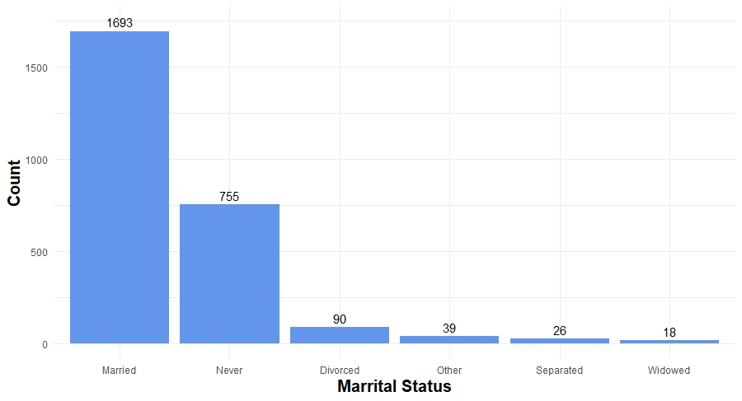

In this study, it is found that the most of respondents (65%) are married. It is also found that, 29% are never married & 0.7% are widowed.

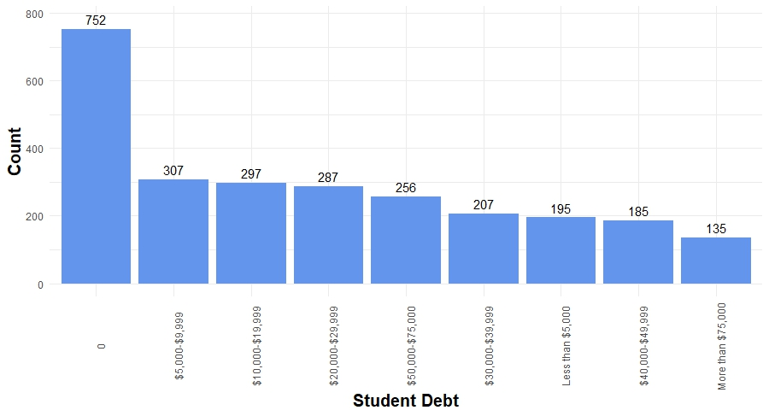

In this study, it is found that 29% of the student have no student loan and 5% of the student have student loan more than $75,000.

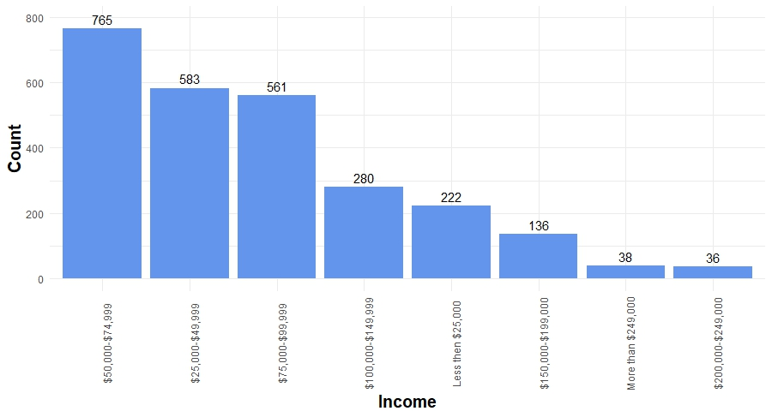

In this study, it is found that the most of the people have between $25,000 to $99,999.

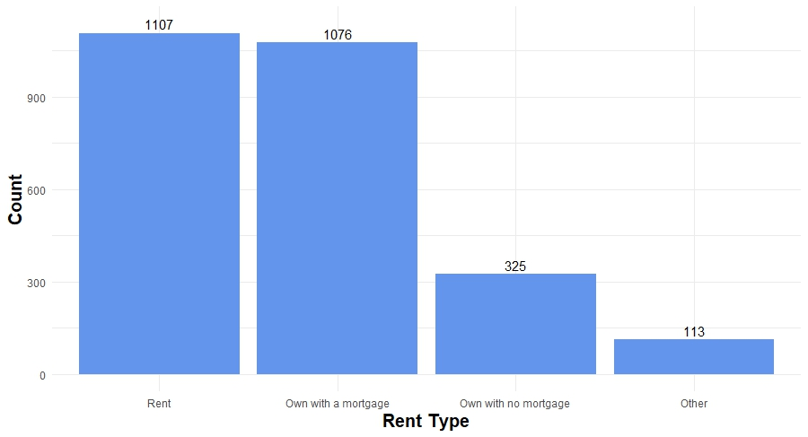

In this study, it is found that 42% & 41% of the respondent have rent house & own house with a mortgage, respectively.

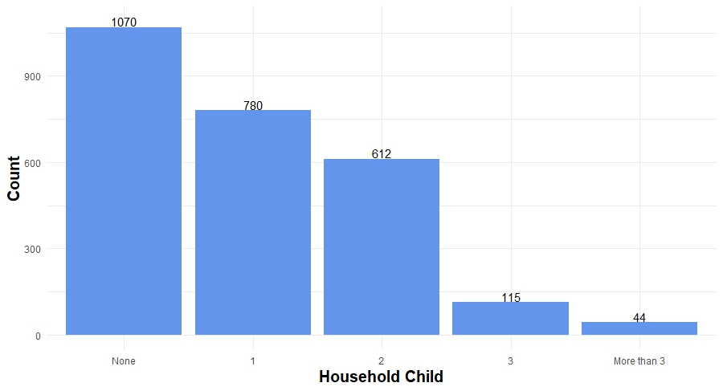

In this study, it is found that 41% of the respondent do not have any child & 1.67% have more than 3 child.

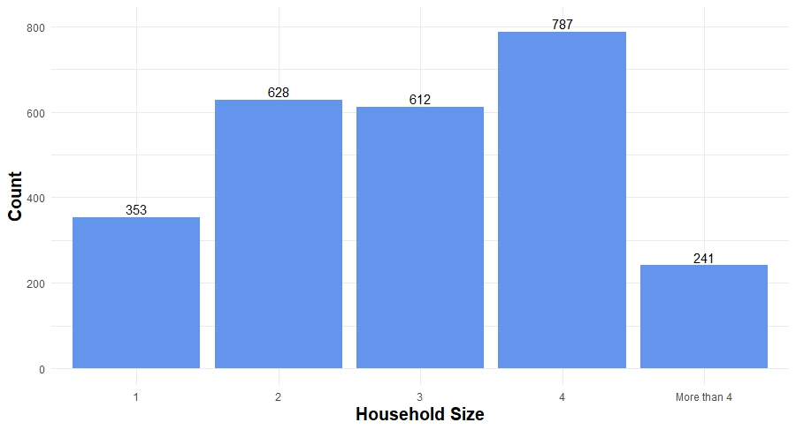

From the figure, it can be noticed that 30% of the respondents have household size 4.

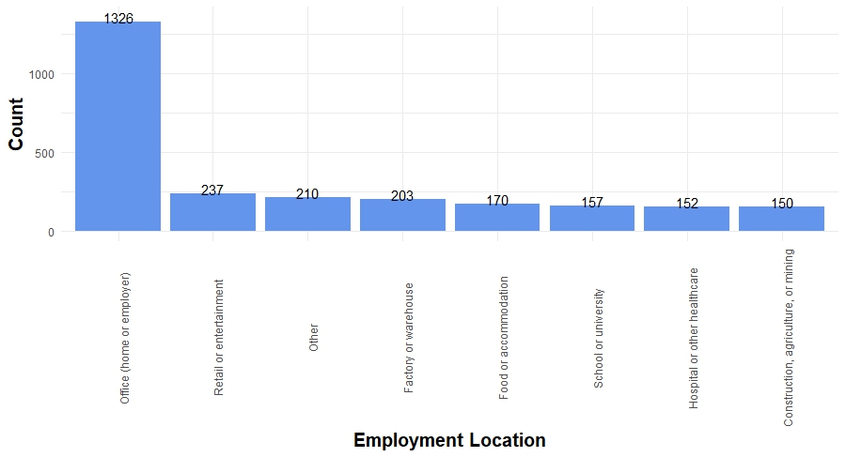

In this study, it is found that the 50% of the respondents work at office.

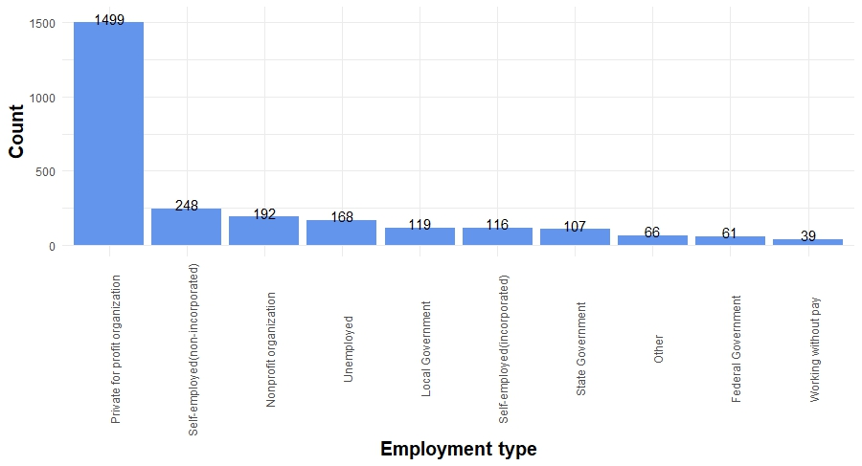

In this study, it is found that the most of the respondents (57%) work at Private for profit organization.

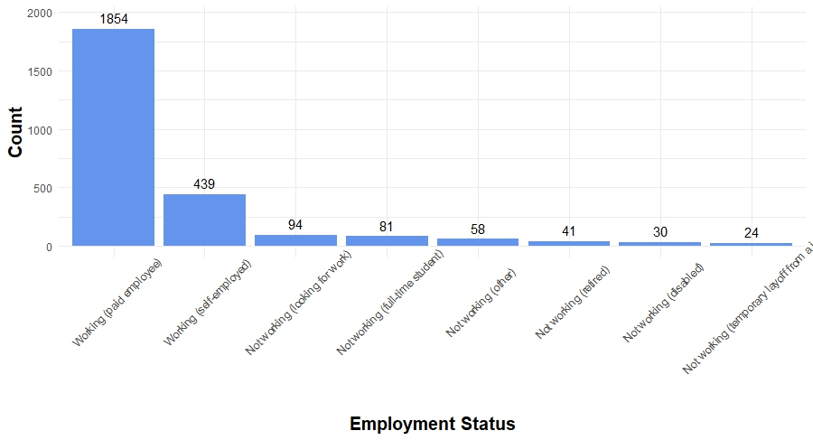

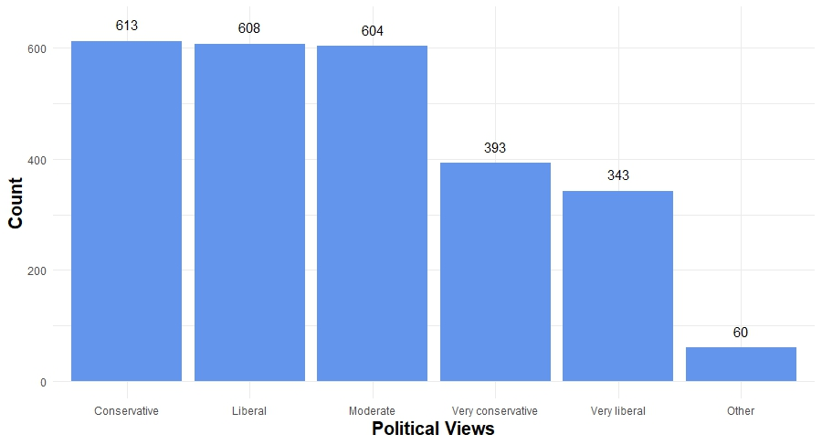

From the figure, it is found that the most of the respondents have political views are Conservative, Liberal & Moderate.

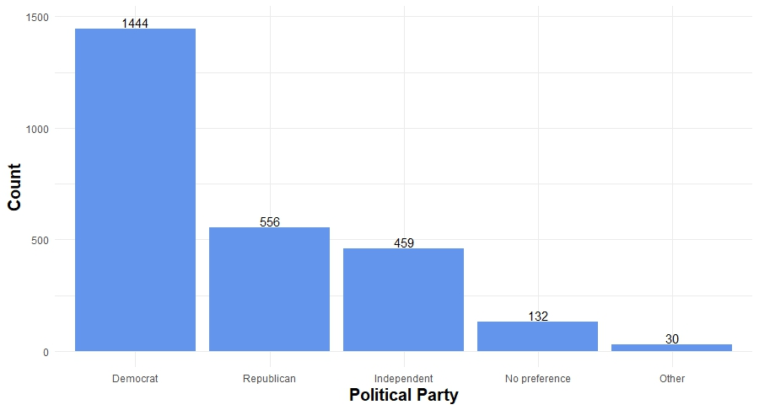

From the figure, it is noticed that 55% of the respondents support Democrat party, 5% have no preference & 1% have other choice.

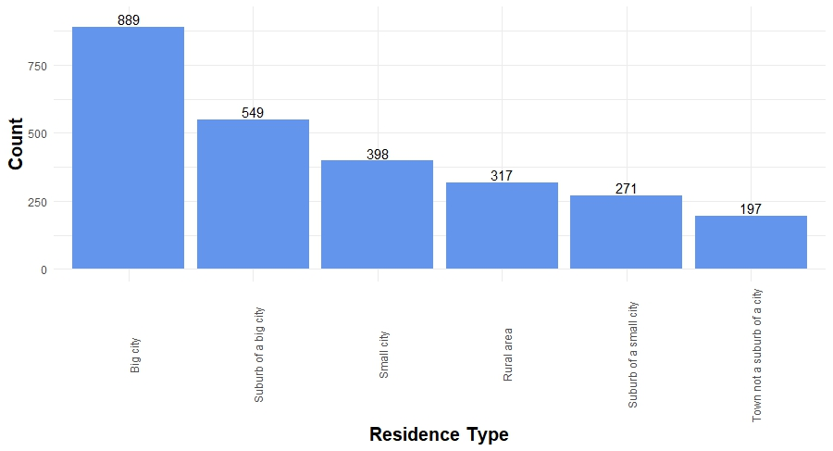

From the figure, it can be seen that the most of the respondents (33%) are from big city.

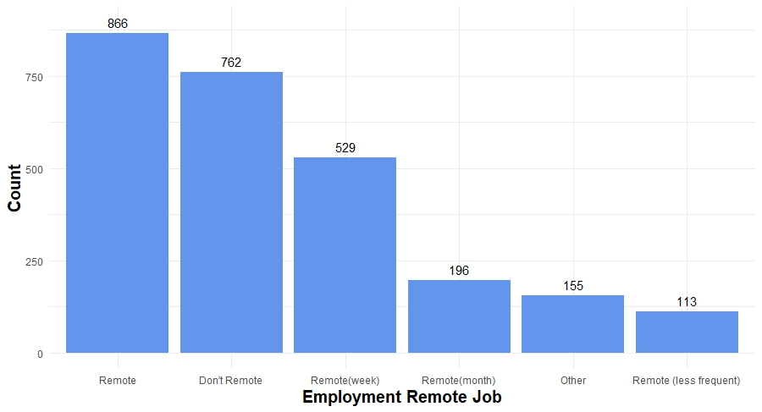

From this figure, it can be noticed that 33% & 29% of the respondents do remote job & do don’t remote job, respectively.